**Gym:** Emerald City, Monroe, WA (1/5/17)

**Trainer:**  Robb

**Fitness Plan**

**Prev (2014):** 183.0 lbs (10%) 164.7 lbs / 18.3 lbs

**Start (10/16):** 186.6 lbs (16.4%) 156.0 lbs / 30.6 lbs

**Today (1/5):** 178.8 lbs (14.7%) 152.5 lbs / 26.3 lbs (+13) / (-12)

**Goal:** 180.0 lbs (8.0%) 165.6 lbs / 14.4 lbs

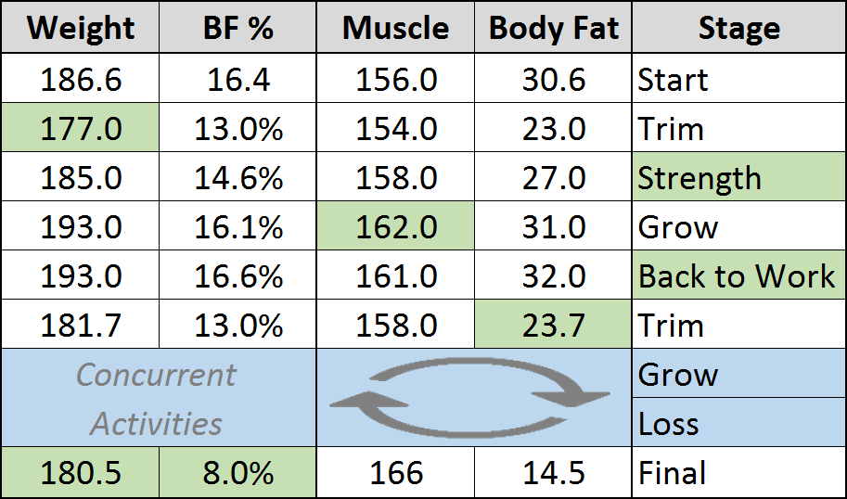 **+10 lbs / -16 lbs**

**Time Target:** 1 year

Start: 11/10/16

Complete: 11/10/17

**Activity Keypoints**

* Plan: Build up a routine that is pointed towards longer

term and establishment of habit

* + You can do extra if desired (e.g. 6 days/wk)
  + Typical high-endurance routine is 4-5 days/wk
* target - 300 minutes over 4 days/wk
* The average healthy weight loss pace is 1 lbs/month

**Note:**

Consider supplementing your diet with a Probiotic and an Amino Acid

* + Your plan calls for at least one year
* Gain muscle first, don’t emphasize weight loss until after
  + “*Convert your weight, it’s not a Lose/Grow game you see*”
  + This minimizes number of cycles and time taken dramatically
  + There will be several rounds to final achieved goals
* Diet and diet-balance are one of the most important long term components of your plan.
  + A primary goal is healthy lifestyle balance, ensure you target something that you can maintain

**Supplemental Nutrients Plan**

Protein (after workout) – 2 Scoops w/Almond Milk

Aminos (after workout) – 1 Scoop

GNC Meal (lunch replace) – 3 Scoops w/Almond Milk

Water (daily) – 10 bottles daily (carried alongside)

**Routine Plan**

Justin will follow the 5-day lift routine established with Robb. Cardio will be interspersed onto lift days in 30m+ segments when possible, in addition to the core pre(10)/post(15) already incorporated. Rest days will occur every 7-14 days.

**Training Plan 2.0 <open>**



**Side Goals**

* Two-Mile run in 14 min (7min mile)
* Flat Bench Press – 6 reps @ 225 lb.
* Achieve (1) Pull-Up
* Torso fitness & aesthetic

**Plan Goals**

* Short-term: (primary: shape) (secondary: strength)
* Long-term: (primary: fitness) (secondary: shape, strength)

**Central Lift Style Points <open>**

**Central Plan Points <open>**

* Always squeeze the shit on grips **during** a lift. Grip strength & muscle activation bloom here!
* Always squeeze on **entry** into a lift and on **exit**. Muscle engagement and activation grow here

**Important Points <open>**

* Don’t lift like a body-builder, 3 sets of 10 is dangerous and generally weak in benefit
* Changing lift sets and rep counts is important!
* Power generation, e.g. jumping or throwing is one of the greatest muscle growth activities

**Key & Vocab <open>**

* *Failure*: performing an exercise to complete exhaustion, while maintaining perfect form. When your form

breaks, you have failed.

**Present Nutrition Plan <open!> ☺**

 



**Configuration**

Robb 🡪 Macros, Calories, Plan Form

Justin 🡪 Micros

**Notes**

(pre-gym) Banana, (post-gym) Protein Shake

Robb has strongly shared the importance of time at the plan, and proper calories (2k/day min)

150g daily protein min, PCF is 30/40/30% at present

**Important Concepts**

“You feed your body what it needs. Weight loss attempts outside of this lose heavy amounts of muscle!”

“The goal is not calories, for Justin it is plan. Can you hit your targets?”

**TDEE – Total Daily Expenditure**

How much energy your body expends in a day, in caloric expression. Stated simply, the calories your body needs in a given day.

TDEE Factors

* Body Physique
* Level of Physical Activity
* Dietary Intake
* Genetics

TDEE Components

* (80%) Basal Metabolic Rate
  + Resting (core body components, like lungs & liver) (70%)
  + Thermo-genesis, the thermic effect of food (10%)
* (20%) Activity Energy Expenditure (wide range)

TDEE Effects

* Height: Up
* Weight: Up
* Age: Down

There are plenty of online calculators and you should use this tooling to establish your state, in different levels (normal, weight-loss, muscle gain).

Justin Calc (12/23/16, 5’11”, 180 lbs., Heavy Excersize 6-7 days/wk, 90 min excersize/day)

[SailRabbit](http://www.sailrabbit.com/bmr/) (2133 calories per day - for losing 1lb per week)

[MuscleForLife](https://www.muscleforlife.com/tdee-calculator/) (2715 calories per day)

[TDEECalculator](https://tdeecalculator.net/result.php?s=imperial&g=male&age=31&lbs=180&in=70&act=1.725&f=1) (3067 calories per day)

[MyTDEE](http://mytdee.com/#gender=male&yr=31&cm=177.8&kg=81.6&bfp=15&goal=lose&goal_kg=80.3&lose_speed=recommended&formula=bfp&units=imperial&exercise=very) (2578 calories per day - recommended), (1934 calories per day - reckless)

[Fitness Frog](http://www.fitnessfrog.com/calculators/tdee-calculator.html) (3217 calories per day)

My Personal Conclusion (for current 7 days/wk lifting plan)

(1900 calories per day - short-term reckless weight loss (1.5 months max)

(2200 calories per day - minimum weight loss general (no limits)

(3100 calories per day - general sustain level) (no limits)

note – Robb calls for 2000 min and I will shoot for this amount, not the 1900 listed above!

**Losing Fat is not Losing Weight!** ([How To Lose Fat Without Losing Muscle – Burn Fat, NOT Muscle](http://www.aworkoutroutine.com/how-to-lose-fat-without-losing-muscle/))

People often say they want to lose weight, meaning they want to be in better shape, and to look better. This in essence means losing fat not weight, dropping the body fat percentage and increasing the muscle mass. This is not aligned with “weight” loss at all, which includes all of you (water, glycogen, muscle, fat, etc!). Well can you lose your muscle mass while only trying to lose body fat? Heck yes, but this takes focused, consistent effort and intent, and this takes time.

The primary and perhaps semi-apparent component then of fat loss is caloric deficit, consuming less than your body needs to perform its tasks for the day. It is important to note then, as described earlier, that simply minimizing this consumption is only the first step. See it turns out your body kind of doesn’t give a shit about what it burns to survive, it burns what is available, and what works given the current conditions and state. And here then is your key.

**Your key is to maximally align and prepare your bodie’s condition, diet and activities for it to then burn fat, while maintaining muscle.**

Here are some keys to this goal.

1. **Eat enough Protein**

* A sufficient daily protein intake is the single most important dietary requirement for maintaining muscle

1. **Maintain Strength/Intensity/Weight On The Bar**

* the primary training stimulus required for maintaining muscle is maintaining your current levels of strength
* On a fat loss diet just maintaining your current levels of strength (aka intensity, aka the weight on the bar) is what now signals your body to maintain muscle
* If that signal goes away, your body’s need to keep your pretty muscle tissue around goes away right along with it
  + That’s why the insanely stupid myth of lifting heavier weights to build muscle but then lifting lighter weights (for higher reps) when you want to lose fat, get lean and get toned is the absolute WORST thing you could possibly believe when you’re trying to avoid losing muscle
  + In reality, you lift heavy weight to build muscle, and then lift that same heavy weight if you want to actually maintain that muscle
* Sure you can continue trying to get stronger and continue trying to make progressive overload happen while losing fat. It can and does happen (especially for beginners, who should still be progressing consistently even in a deficit)

1. **Reduce Weight Training Volume and/or Frequency**

* A caloric deficit is really an energy deficit, and while this is fantastic (and required) for losing any amount of body fat, it eliminates energy for the rest of your time and life
* If not reduced, this regimine can actually lead to strength loss (lifting a lot with insufficient energy available!)

1. **Get Pre & Post Workout Nutrition Right… Still**

* Pre and Post workout nutrition is centered on the maximization of effect in training and recovery from training periods, which is directly aligned with your weight loss plan's point of excercize - maximizing effect of this time spent!

1. **Don’t Reduce Calories By TOO Much**

* A moderate deficit of about 20% below maintenance level is what ends up being most ideal in most cases
* Reducing your calorie intake by TOO much will increase the potential for strength and muscle loss

1. **Avoid Excessive Amounts Of Cardio (Or Just Don’t Do ANY At All)**

**Rob’s Key Routine Points**

Posterior: Balance

- Resist Gravity

- Posture

- Balance in Movement

- Bringing Objects toward our center of gravity

Muscle Groups -

- Soleus

- Hamstrings

- Glutes

- Spinal Stabilizers

- Lats

- Rhomboid

- Rear Delts (Back)

- Transverse Abdominal (Plank)

Anterior: Frontline

- Provide Movement (Flexion)

- Move Objects Away from Center of Gravity

Muscle Groups -

- Quadriceps

- Gastrocnemius (Calf)

- Peltus Abdominus (Transverse Abdominus, your abs?)

- Pectorals

- Anterior Deltoid

- Triceps

Legs/Core

Stable Stance

- Squat (Raw Strength & Core/Hip Stability)

Split Stance

- Lunge (Coordination/Balance, Core/Hip Mobility)

Sample Week

1 - Legs (Always)

2 - Posterior (Always)

3 - Anterior

4 - Legs (Always First Extra)

5 - Push/Pull (Upper Body "fun", practicing and maintaining posture)

6 - Cardio/Mobility/Core

7 - Cardio/Mobility/Core

**Anterior Day II (pending)**

Justin is looking to merge this with Day I, and modify it based on his research and ideas



**A Challenge**

8% by July 2017, game on -

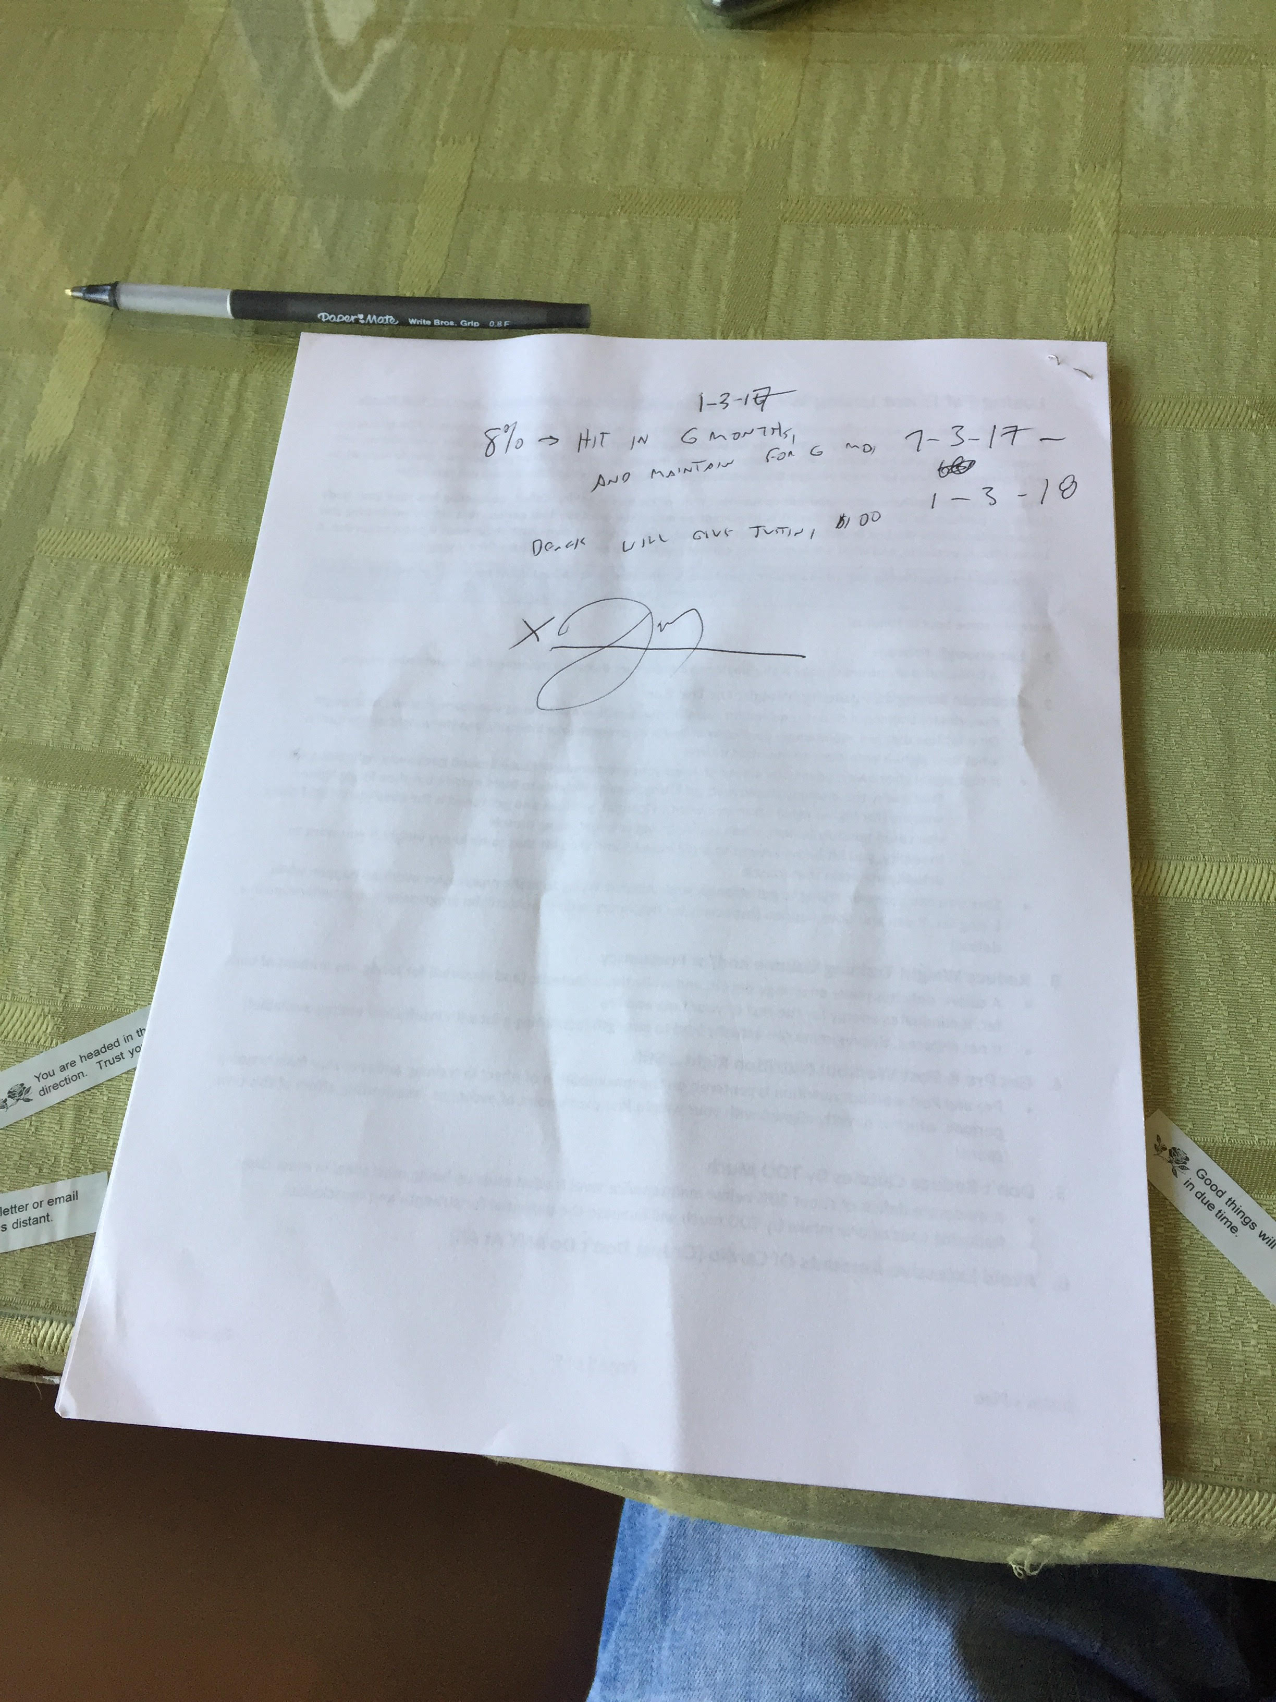

This means 7% body fat loss, 14 pounds in six months, or 14 pounds in 3 months for reasonable estimation.

14 lbs / 12 weeks -> 1.2 lbs / week

I have been at the pace of 1 pound per week for the past month, this appears quite achievable!